**Data Mart Analysis**



**INTRODUCTION:**

Data Dart is my latest venture and I want your help to analyze the sales and performance of my venture. In June 2020 - large scale supply changes were made at Data Mart. All Data Mart products now use sustainable packaging methods in every single step from the farm all the way to the customer.

I need your help to quantify the impact of this change on the sales performance for Data Mart and its separate business areas.

**SCHEMA USED: WEEKLY_SALES TABLE**

|  |  |
| --- | --- |
| Column name | Data type |
| week_date | date |
| region | varchar(20) |
| platform | varchar(20) |
| segment | varchar(10) |
| customer | varchar(20) |
| transactions | int |
| sales | int |

**CASE STUDY QUESTIONS**

## Data Cleansing Steps

In a single query, perform the following operations and generate a new table in the data_mart schema named clean_weekly_sales:

1. Add a week_number as the second column for each week_date value, for example any value from the 1st of January to 7th of January will be 1, 8th to 14th will be 2, etc.
2. Add a month_number with the calendar month for each week_date value as the 3rd column
3. Add a calendar_year column as the 4th column containing either 2018, 2019 or 2020 values
4. Add a new column called age_band after the original segment column using the following mapping on the number inside the segment value

|  |  |
| --- | --- |
| segment | age_band |
| 1 | Young Adults |
| 2 | Middle Aged |
| 3 or 4 | Retirees |

1. Add a new demographic column using the following mapping for the first letter in the segment values:

segment | demographic |  
C | Couples |  
F | Families |

1. Ensure all null string values with an "unknown" string value in the original segment column as well as the new age_band and demographic columns
2. Generate a new avg_transaction column as the sales value divided by transactions rounded to 2 decimal places for each record

## B. Data Exploration

1. Which week numbers are missing from the dataset?
2. How many total transactions were there for each year in the dataset?
3. What are the total sales for each region for each month?
4. What is the total count of transactions for each platform?
5. What is the percentage of sales for Retail vs Shopify for each month?
6. What is the percentage of sales by demographic for each year in the dataset?
7. Which age_band and demographic values contribute the most to Retail sales?

Table-

select * from weekly_sales;

## 

Solution

Data Cleansing

/* Data Cleaning*/

SELECT

week_date,

DATEPART(WEEK, week_date) AS week_number,

DATEPART(MONTH, week_date) AS month_number,

DATEPART(YEAR, week_date) AS calendar_year,

region,

platform,

CASE

WHEN segment = 'null' THEN 'Unknown'

ELSE segment

END AS segment,

CASE

WHEN RIGHT(segment, 1) = '1' THEN 'Young Adults'

WHEN RIGHT(segment, 1) = '2' THEN 'Middle Aged'

WHEN RIGHT(segment, 1) IN ('3', '4') THEN 'Retirees'

ELSE 'Unknown'

END AS age_band,

CASE

WHEN LEFT(segment, 1) = 'C' THEN 'Couples'

WHEN LEFT(segment, 1) = 'F' THEN 'Families'

ELSE 'Unknown'

END AS demographic,

customer_type,

transactions,

sales,

ROUND(

sales / transactions,

2

) AS avg_transaction

INTO clean_weekly_sales

FROM weekly_sales;

SELECT TOP 10 * FROM clean_weekly_sales;

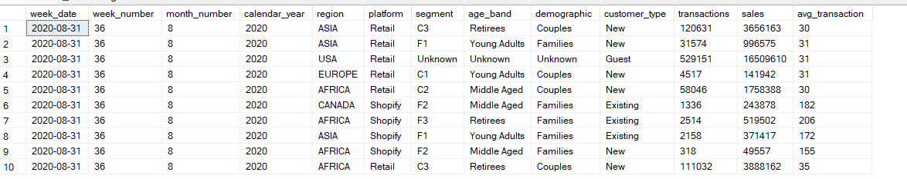

## Data Exploration

**Task 1 -** Which week numbers are missing from the dataset?

Solution-

CREATE TABLE #WeeksReference (WeekNumber INT);

INSERT INTO #WeeksReference (WeekNumber)

VALUES

(1), (2), (3),(4),(5),(6),(7),(8),(9),(10),

(11),(12),(13),(14),(15),(16),(17),(18),(19),

(20),(21),(22),(23),(24),(25),(26),(27),(28),(29),(30),

(31),(32),(33),(34),(35),(36),(37),(38),(39),(40),

(41),(42),(43),(44),(45),(46),(47),(48),(49),(50),(51),(52);

select distinct WeekNumber as week_day from #WeeksReference

where WeekNumber not in(select distinct week_number from clean_weekly_sales);

select distinct week_number from clean_weekly_sales;

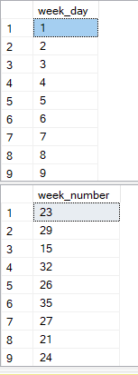

**Task 2-** How many total transactions were there for each year in the dataset?

Solution-

SELECT

calendar_year,

SUM(transactions) AS total_transactions

FROM clean_weekly_sales group by calendar_year;

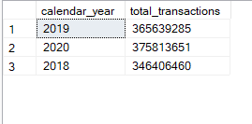

Task 3-What are the total sales for each region for each month?

Solution-

ALTER TABLE clean_weekly_sales

ALTER COLUMN sales BIGINT;

SELECT

month_number,

region,

SUM(sales) AS total_sales

FROM clean_weekly_sales

GROUP BY month_number, region

ORDER BY month_number, region;

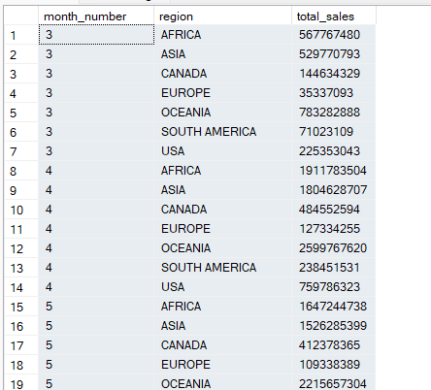

Task 4 - What is the total count of transactions for each platform?

Solution –

SELECT

platform,

SUM(transactions) AS total_transactions

FROM clean_weekly_sales

GROUP BY platform;

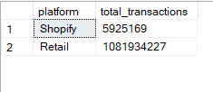

Task 5-What is the percentage of sales for Retail vs Shopify for each month?

Solution –

WITH cte_monthly_platform_sales AS (

SELECT

month_number,calendar_year,

platform,

SUM(sales) AS monthly_sales

FROM clean_weekly_sales

GROUP BY month_number,calendar_year, platform

)

SELECT

month_number,calendar_year,

ROUND(

100 * MAX(CASE WHEN platform = 'Retail' THEN monthly_sales ELSE NULL END) /

SUM(monthly_sales),

2

) AS retail_percentage,

ROUND(

100 * MAX(CASE WHEN platform = 'Shopify' THEN monthly_sales ELSE NULL END) /

SUM(monthly_sales),

2

) AS shopify_percentage

FROM cte_monthly_platform_sales

GROUP BY month_number,calendar_year

ORDER BY month_number,calendar_year;

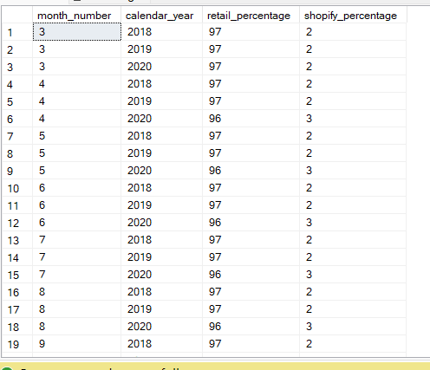

Task 6-What is the percentage of sales by demographic for each year in the dataset?

Solution-

SELECT

calendar_year,

demographic,

SUM(SALES) AS yearly_sales,

ROUND(

(

100 * SUM(sales)/

SUM(SUM(SALES)) OVER (PARTITION BY demographic)

),

2

) AS percentage

FROM clean_weekly_sales

GROUP BY

calendar_year,

demographic

ORDER BY

calendar_year,

demographic;

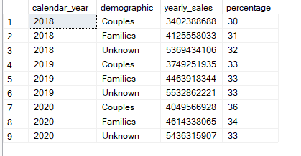

Task 7 -Which age_band and demographic values contribute the most to Retail sales?

Solution –

SELECT

age_band,

demographic,

SUM(sales) AS total_sales

FROM clean_weekly_sales

WHERE platform = 'Retail'

GROUP BY age_band, demographic

ORDER BY total_sales DESC;

